# DAILY ASSESSMENT

|  |  |  |  |
| --- | --- | --- | --- |
| Date: | 1/07/2020 | Name: | GAURAV N R |
| Course: | **IIRS** | USN: | 4AL15EC025 |
| Topic: | **Concepts of satellite photogrammetry** | Semester & Section: | 8TH SEM & A Section |
| Github Repository: | gaurav |  |  |

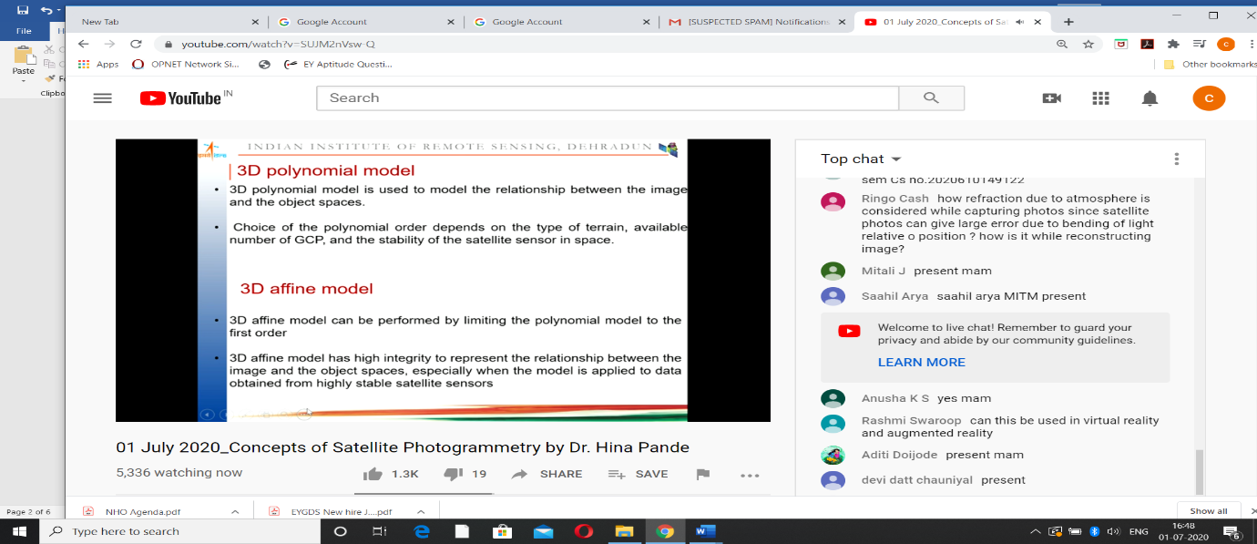

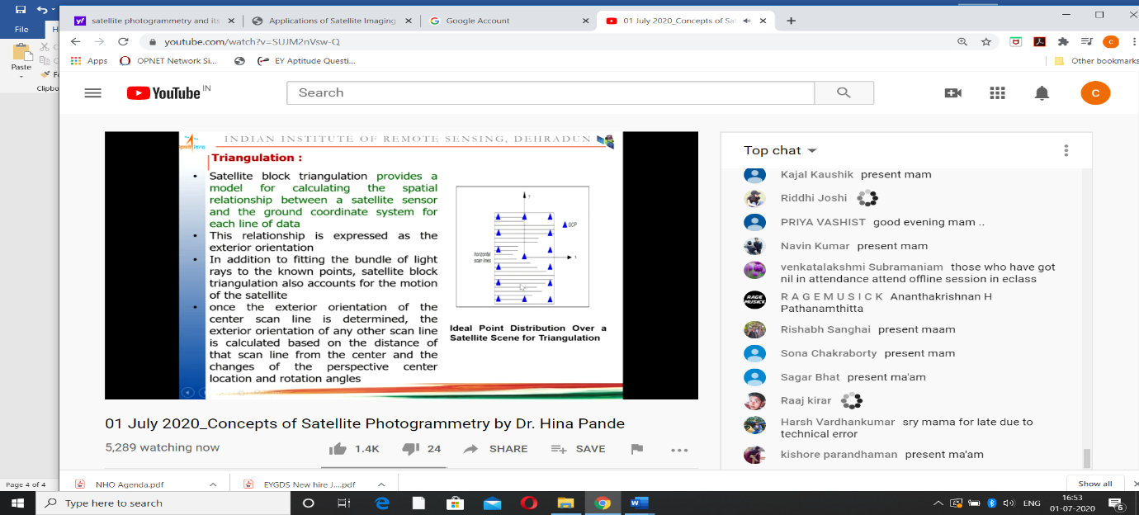

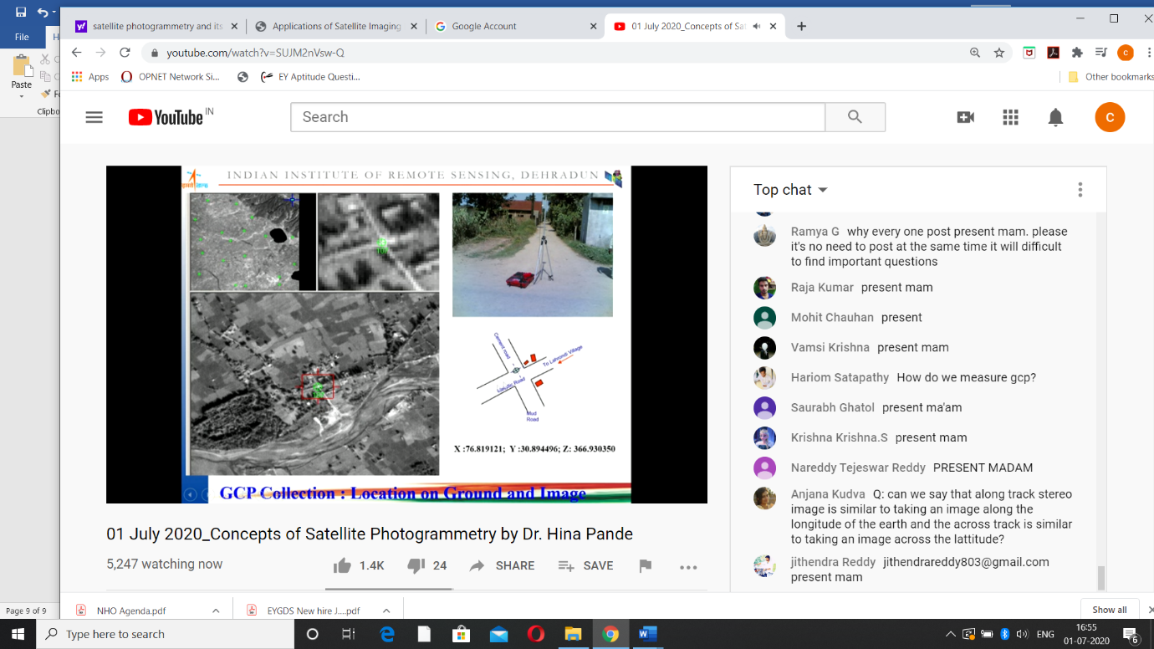

Imaging radar systems (Radio Detection and Ranging) were developed in the 1950s mainly by the armed forces. Radar is an active remote sensing system which means that it provides its own source of energy to produce an image. It therefore does not require sunlight (as do optical systems) and data can be acquired either by day or by night. Furthermore, due to the specific wavelength of radar, cloud cover can be penetrated without any effect on the imagery.

Synthetic Aperture Radar (SAR) is a technique for creating high resolution images of the earth's surface. Over the area of the surface being observed, these images represent the backscattered microwave energy, the characteristics of which depend on the properties of the surface, such as its slope, roughness, humidity, textural inhomogeneities and dielectric constant. These dependencies allow SAR imagery to be used in conjunction with models of the scattering mechanism to measure various characteristics of the earth's surface, such as topography. SAR has become a valuable remote sensing tool for both military and civilian users. Military SAR applications include intelligence gathering, battlefield reconnaissance and weapons guidance. Civilian applications include topographic mapping, geology and mining, oil spill monitoring, sea ice monitoring, oceanography, agricultural classification and assessment, land use monitoring and planetary or celestial investigations.  
   
 Another highly active research area in radar remote sensing is repeat pass satellite SAR interferometry (InSAR). InSAR provides a means for measuring displacements of the solid earth, glaciers, ice sheets, and fast sea ice to an accuracy of fractions of a radar wavelength (a few cm) during the time intervals between observations, using synthetic aperture radar (SAR) imagery. Since the launch of the first European Remote Sensing satellite (ERS-1) in 1991, this rapidly-evolving technology has been employed to measure, for example, coseismic displacements; the motion of glaciers and ice sheets in Alaska, Greenland, Antarctica and elsewhere; retreat of the grounding line of a major West Antarctic ice stream; deflation of a European volcano following an eruption; and crustal extension of potentially active volcanic vents in SW Alaska.

In addition, InSAR can be employed to derive digital elevation models (DEMs) of the Earth's surface. Other applications of InSAR include prediction of earthquakes and volcanic eruptions, ice flow mapping, forest mapping and land classification. The limitations caused by atmospheric effects presently seem to be the most fundamental and severe limitation for this otherwise incredibly sensitive technique. Furthermore, the correlation map that used to be "just" a byproduct of the interferometric processing, and at best a measure of the interferogram quality, is now becoming important information in itself. Correlation maps are used for volume scattering estimation and forest height measurement as well as for land use classification.

Another application area in radar remote sensing is hydrology, including the retrieval of soil moisture and snow water content, glaciology, and radar mapping of vegetation. Hydrology is an area where SAR and also active imaging radar of lower resolution have much to offer. In relation to soil moisture estimation, polarimetric data have proven capabilities. Difficult problems include the vegetation cover and the requirement that the soil type/texture needs to be known. There is, however, hope that these problems can be mitigated. Using lower frequencies, e.g. P-band, enables penetration of low to moderate vegetation. More interestingly, the soil texture can potentially be estimated from a time series of measurements during a drying period following precipitation.

## Remote Sensing Platforms and Sensors

The following is a list of some of the more well-known spaceborne remote sensing platforms and sensors. A more complete list can be obtained from http://quercus.art.man.ac.uk/rs/sat_list.cfm which currently lists 87 remote sensing platforms and sensors.

ERS-1/2

- European Remote Sensing Satellite 1 and 2. The first satellite in the ERS series was launched in June 1991, and its successor (ERS-2) in April 1995. Since 1991, an almost global coverage of the Earth's surface has been attained with the satellite's SAR (Synthetic Aperture Radar) instrument. The ERS satellites have Sun-synchronous, near polar, quasi- circular orbits with a mean altitude of 785 km and an inclination of 98.5° . Most of the ERS-1 mission was performed with a 35-day cycle. ERS-2 only operates in a fixed repeat cycle of 35 days, which means that a particular site is covered every 16 days (figures for Equator latitude).

JERS-1

- Japanese Earth Resources Satellite - 1.

LightSAR

- A JPL lead US project, "low-cost", lightweight, L-Band system, focused on interferometric SAR applications, e.g. natural hazards (seismic and volcanic deformation), ice flow velocity mapping; and low frequency applications, including biomass mapping, soil moisture, and snow water equivalent mapping.

RADARSAT

- Commercial, very similar to ERS.

SEISM

- Solid Earth Interferometric Spaceborne Mission, a French concept, based on the basic idea of implementing a low cost SAR which will extend the ERS-1/2 capability and ensure acquisition of data for very long time span interferograms in areas where coherence allows such long baselines. Key applications would for instance be forest clear-cut monitoring.

SIR-C/X-SAR

- Shuttleborne Imaging Radar.

SRTM

- Shuttle Radar Topography Mission.

|  |  |
| --- | --- |
|  |  |

The SRTM mission is an important milestone in the history of remote sensing. In eleven days it collected about 18 Terabytes of radar measurements which will allow scientists to virtually reconstruct a 3-dimensional model of 80% of the Earth's continental area. The collected radar images will be converted to digital elevation models (DEMs) spanning the globe between 60° North and 58° South. The "virtual Earth" will be reconstructed as a mesh of 30 m spacing, and is accompanied for each point by a measure of the reflected energy of the radar signal, the intensity image. These data will become an important reference for comparison and correlations with older and future satellite or other Earth Observation (EO) data. SRTM is a valuable asset for many applications ranging from geology, tectonics, hydrology, cartography, to navigation and communications.

## Remote Sensing Applications by Instrument

## Wind Scatterometer (WSC) Applications

Wind scatterometers use accurate measurements of the radar backscatter from the ocean surface when illuminated by a microwave signal with a narrow spectral bandwidth to derive information on ocean surface wind velocity. At a given angle to the flight path of the satellite, the amount of backscatter depends on two factors, namely the size of the surface ripples of the ocean and their orientation with respect to the propagation direction of the pulse of radiation transmitted by the scatterometer. The first is dependent on wind stress and hence wind speed at the surface, while the second is related to wind direction.

Scatterometer instruments aim to achieve high accuracy measurements of wind vectors, and resolution is of secondary importance. The resolution of the ERS scatterometer is 50 km, though the grid sampling is 25 km. Because the scatterometer operates at microwave wavelengths, the measurements are available irrespective of weather conditions. The assimilation of scatterometer data into atmospheric forecasting models greatly improves the description of cyclonic features so important in predicting future weather patterns. There are numerous other applications, such as the measurement of sea ice extent and concentration, and emerging land applications such as regional-scale monitoring of ice shelves, rainforests and deserts.

**Radar Altimeter (RA) Applications**

The radar altimeter is designed to make accurate measurements of the satellite's height above the sea surface which is then converted to the sea surface's height above a reference ellipsoid. When the altimeter takes a height measurement, it is measuring a height contributed to by many different types of phenomena, from the underlying marine geoid, through the large-scale general circulation of the oceans, to mesoscale eddies 100 km across. In addition to highly precise height measurements, the altimeter makes measurements of the heights of waves that appear in its footprint, and of surface wind speed.

**Applications of the radar altimeter include:**

* Measuring the marine geoid.

Information has been extracted from altimeter data, particularly that provided by the high resolution dedicated Geodetic Mission of ERS-1, to provide maps of average sea surface topography - the marine geoid. The geoid is the fundamental reference surface of geodesy. Through its use in geoid determination, altimetry aids in revealing the location of ocean floor features such as faults, trenches, spreading zones, sea mounts and hot spots. Information may also be gained on the age, structure and dynamics of the lithosphere, particularly in the area of subduction zones, leading to a better understanding of the relationship between the lithosphere and the mantle, and of mantle convection. Additional, commercially valuable information can be derived on potential locations of oil-bearing structures using the effect that low density deposits (such as crude oil) have on the shape of the gravity field. This information has been derived not only over oceans, but also in the Arctic Ocean, using altimetry over sea ice.

* Measuring sea state.

The radar altimeter also measures the heights of waves that appear within its `footprint', and the wind speed at the sea surface. Near real time measurements of Significant Wave Height (SWH) by the ERS altimeter are assimilated operationally into wave models to provide wave forecasts, essential for the optimisation of a range of marine operations.

* Measuring the topography of the oceans.

Worldwide sea level varies significantly in space and time. Regional variations in sea level occur as a result of pressure differentials within the ocean, which result from momentum and heat flux exchange with the atmosphere. The resultant differences in sea level are thus directly related to ocean currents. Ocean topography can be measured directly and monitored for change using the ERS radar altimeter. Along with data from other similar instruments, the information can be assimilated into ocean circulation models which transform satellite surface information into three-dimensional descriptions of ocean currents and transports. An important fluctuation in the ocean-atmosphere system is the El Nino Southern Oscillation (ENSO) phenomenon, which causes an increase in ocean temperatures throughout the central and tropical Pacific which can produce dramatic changes in climate on the timescale of months to years. The events associated with ENSO can be measured in sea surface topography by the ERS altimeter, and in sea surface temperature by the ERS Along Track Scanning Radiometer (ATSR).

**Along Track Scanning Radiometer (ATSR) Applications**

Remote sensing data from the ERS-2 ATSR-2 allows the monitoring of agricultural fires and wildfire distribution on a global scale and in near real time. All hot spots (including gas flares) with a temperature higher than 312 K at night are precisely located (better that 1 km). Data from the ATSR sensor is also used for volcano monitoring applications and measuring ocean skin temperatures.

### Global Ozone Monitoring Experiment (GOME) Applications

Atmospheric ozone and NO2 global monitoring have been going on since GOME products became available (July 1996). Additional applications could stem from on-going scientific studies, as GOME data can also be used for retrieving other trace gases relevant to the ozone chemistry as well as other atmospheric constituents and climatic variables like clouds, aerosols and solar index, all of which are crucial for assessing climate change.

### Microwave Sounder (MWR) Applications

The ERS-2 microwave sounder is being used to monitor the Antarctic ice cycle. Mapping the radiometric properties of the ice-shelf, which has a slower time evolution than the atmosphere and the ocean, provides a valuable input for the understanding of the growth, decay and dynamics of ice sheets. This in turn is fundamental to the understanding of environmental and climatic changes.